LAB 8 Validation

**Using the solution from Lab 7:**

1. Add Validation for the User & Address.

For User:

First & Last Name should have a value & more than 4 characters & less than 20.

Validate email [@Email]

Ranking must be greater than 8.

Address:

Zip code must be between 5 & 9 digits [Try using Min/Max or Range]

Need to complete the errorMessages.properties file

Need to Annotate the Service methods with the provided ServiceValidation annotation

RENAME your project to Lab_8_ValidationSol [submit this for assignment]

Here is what New user looks like:

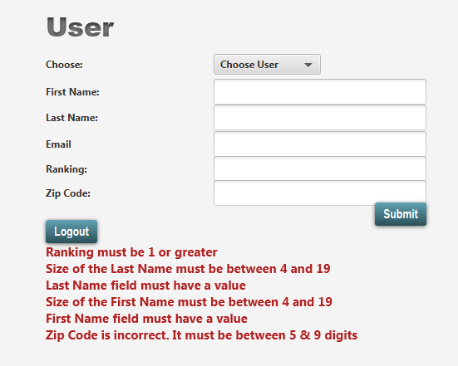

**Part 2:**

1. Add Validation groups for User

Rename Lab_8_ValidationSol to Lab_8_ValidationGroupSol [submit this for assignment]

Do NOT use AOP for validation.

Do NOT use the validation process from the class demo.

INSTEAD

There is a method with the signature in the UserServiceImpl.java:

**public** Boolean validate(User user, Class<?> group)

It will need to invoked from the UserService save method AND the update method.

You will need to remove the ServiceValidationAnnotation

The save method will validate according to the Default group.

The update method will validate according to the Details group.

Change the hasRole on the User save to ROLE_ADMIN

SO:

Sean as Admin can create [ call save method]

Paul as Supervisor can update [ call update method]

For User:

First & Last Name be in the Default group

Email in the Details group

Ranking must be in the Details group

Address:

Zip code must be in the Default group

Here is Results of Sean “saving” an empty user.

Notice the “weird” field names ….We are using Hibernate Validator which isn’t as robust as Spring Validator W/R to field names…

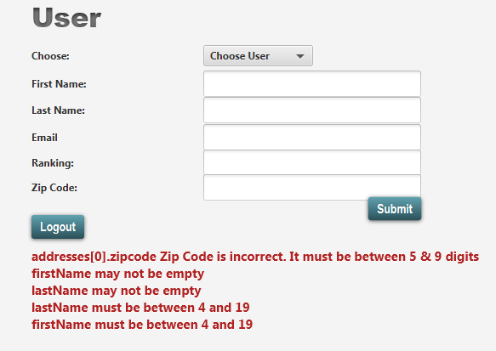

Here is save WITHOUT validating email OR Rank [ only on update]…

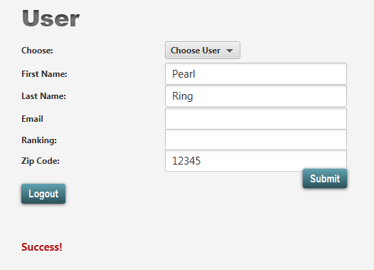

User Paul [update]

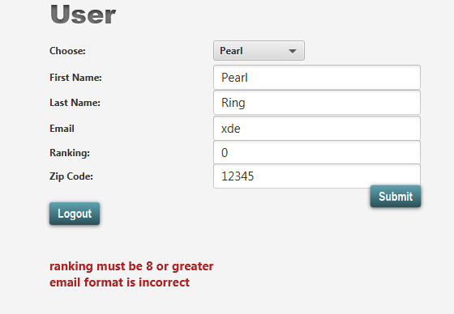

Paul – Update – valid fields

